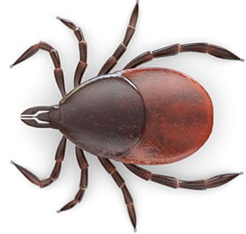

The Lyme Disease General Practice Sentinel Scheme (Pilot)
Our practice is participating in a pilot scheme to help NHS Highland collect better information on Lyme Disease.
Lyme Disease is caused when an infected tick attaches itself onto a human and passes on bacteria that can cause a range of symptoms.
Lyme Disease can affect people in lots of different ways, which means there are several ways in which suspected Lyme Disease can be managed and lots of different terms which can be used to record it in the patient’s notes. Often there is uncertainty about the diagnosis when patients first see their GPs.
This scheme aims to help doctors by supplying them with guidance on diagnosing, treating and recording Lyme Disease to ensure quick and more consistent treatment for patients. This in turn will allow us to collect better information on how many people in the Highlands are affected by Lyme Disease, where they got it and how it is managed by GPs.
How does it affect me?
This practice has agreed to use a guidance tool that works with our computer system to identify cases and record them accurately and consistently in patient notes with special computer codes. If you attend the practice having been exposed to a tick and / or with Lyme Disease symptoms, your doctor or nurse will use this tool to gather more detailed information related to tick bites and Lyme Disease. Your doctor will be able to use the tool to access guidance on managing Lyme Disease and will be asked to record their diagnosis against a specified list of electronic codes.
If you have a rash as a result of Lyme Disease, you may be asked if you would consent to a photo of this being taken (the consent form gives further details of how photographs may be used).
The project will not affect the treatment you are given. If you need antibiotics or blood tests these will be done as normal.
Please contact the practice if you would like more information or you can contact the NHS Highland project team at nhsh.lymegpss@nhs.scot

Dr Douglas has also made a couple of suggestions of useful links you might like to put up on your practice website. These hold useful and accurate information that may be useful for both people who work and spend a lot of time in the outdoors and also just for anyone who is unsure what to look for or how to deal with ticks. The links are below and are optional.
https://www.youtube.com/watch?v=jAG2wI9EiNM - tick removal video
https://forestryandland.gov.scot/what-we-do/health-safety-wellbeing/lyme-disease-and-tick-awareness

